High Resolution Wind Direction Encoder

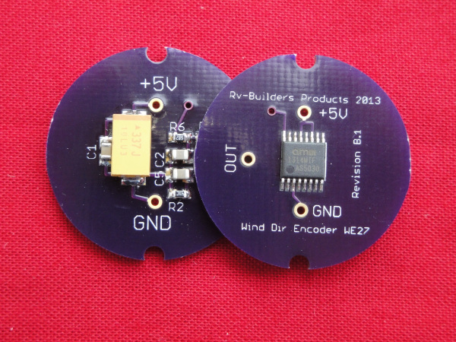

# Description

Based on a quad Hall effect sensor the device reads the direction of a magnetic field provided by a small diametrically polarized magnet rotating above it. The device provides a linear voltage between 0 and 3.3V coinciding with the absolute angle of the magnet and has no dead band in the full 360 degree swing. The sensor, being completely solid state asserts no drag on the vane and has no mechanical parts to wear out.

# Applications

* High definition/resolution wind direction monitoring & recording
* Maintenance free
* DIY and custom weather stations

# Features

* Drag free
* Maintenance free, solid state
* No blind spots in full circle
* No false readings due to partially worn potentiometer.
* Interfaces direct to microcontroller ADC inputs
* Built in Hysteresis for jitter free output signal.

# Electrical specifications

* Input voltage nominal 5V, maximum 5.5V
* Desired ADC input impedance > 100K
* DC output impedance ~ 10K
* Current consumption 18 mA @5V

# Connections

|  |  |  |  |  |
| --- | --- | --- | --- | --- |
| Name | Symbol on PCB | Description | Condition | |
|  | | | | |
| Ground | GND | Ground reference | -- | |
| Power | +5V | Regulated power input | 5V +/- 5% , less than 50mv noise | |
| Output Signal | OUT | ~0V to ~3.3V coinciding with angle 0-360 degree | Low <0.1V, | High <3.3>3V |

# Mechanical specifications

* PCB dimension: Rround, 1” diameter
* Sensor to magnet distance 1.5mm +/- 10%

+5V regulated supply

System Ground

Output Signal

0 deg

360 deg.